

***Instructions: Leaders are welcome to use this document as is or make changes to accommodate the needs of their troop. Please remove these instructions prior to utilizing this document.
Troop # ____________________
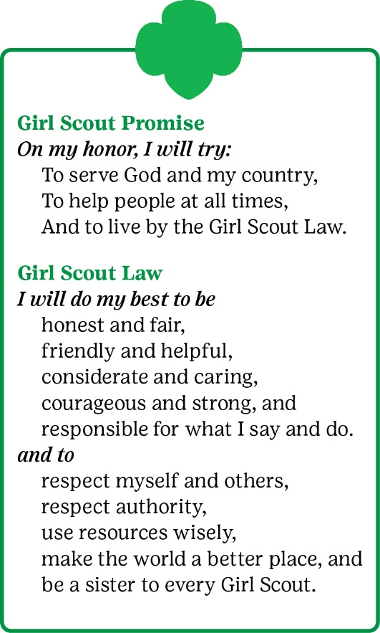
Our mission is to build Girl Scouts of courage, confidence, and character who make the world a better place. To do this, we strive to work together in creating a fulfilling, safe, and inclusive environment for everyone modeled after the Girl Scout Promise and Law. Please sign this document, pledging that you will help build a positive and encouraging environment for everyone.
Youth Agreement – I will:
          - Do my best to honor the principles of the Girl Scout Promise and Law through my words and actions.
          - Follow all troop safety guidelines.
          - Honor my commitments.
          - Stand up for what is right.
          - Work with others to find solutions for disagreements.
          - Be respectful to the troop leaders and volunteers.
If I do not abide by the Girl Scout Promise and Law and follow the troop Code of Conduct, troop leaders may:
- Ask for my behavior to change and follow the expectations outlined in the troop agreements.
- Remove me from the activity to discuss the troop agreements and how to correct my behavior.
- Request a meeting with my caregiver to ask for assistance in resolving the issue.
- Require my caregiver’s attendance at future meetings and trips.
- Seek assistance from Girl Scouts of Northern Illinois regarding the situation and to possibly find an alternate activity for me.
Caregiver Agreement – I will:
- Model the principles of the Promise and Law for my youth.
- Support my youth in honoring the Troop’s Code of Conduct.
- Be cooperative, honest, and respectful.
- Arrive on time to drop off and pick up my youth.
- Abide by my troop’s drop off and pick up procedures.
- Provide current emergency contact information to the troop leaders.
- Inform leaders of circumstances that may affect my youth’s welfare (ex. providing information and legal documentation about additional individuals picking them up).
- Notify troop leaders if my youth is unable to attend a meeting or activity.
- Find solutions for any disagreements in a private and appropriate manner.
- Respect the troop leaders’ time, energy, and resources in a non-paid, volunteer position.

Please tear off this portion and return to your troop leaders.

Youth Name__________________________________________ Date_____________

We agree to accept the Girl Scout Promise and Law, follow the troop’s Code of Conduct, and always display appropriate behavior.

____________________________________ _______________________________________
Youth Signature Caregiver Signature

