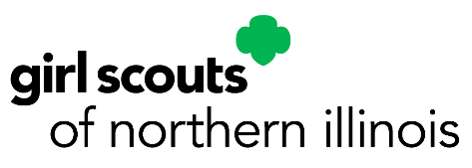
Insert Patch or fun graphic!
[Event Name]
[Event Date] [Event Time]
[Event Location]
[Event Description]

This event is for [Levels that can attend]
Cost per Girl Scout is [$], Cost per Adult is [$]
[Tag-a-longs are not allowed or Tagalongs are allowed. Cost is [$]]
[Patch included/Patch not included]
[This is a bring-a-friend event. Note cost if different.]
[Troop is required to provide adult/member ratio or Parent must attend with member.]

Registration Deadline is [Date].
To register: Mail permission form and payment to: [name and address of event planner]

Checks Payable to: Girl Scouts of Northern Illinois
If you have any question, please contact [Event planner name] at [phone number] or [Email].
My Girl Scout, _____________________________, has permission to participate in [Event Name].
They are in good physical condition and has not had any serious illness or operation since last health examination.
During this activity, I may be reached at: Phone (______) _______________ Cell (_______)__________________
If I cannot be reached in the event of an emergency, the following person is authorized to act on my behalf:
Name:____________________________________________ Relation to Participant__________________________
Address _________________________________________________ City_______________________
Phone (_______) ______________ Cell (______)__________________
Physician’s name __________________________ Phone (________) _________________________
Special Considerations______________________________________________________________________________
_________________________________________________________________________________________________
The bearer of this letter has my permission as a parent or legal guardian to act on my behalf in any emergency dealing with the health and welfare of my Girl Scout and to obtain emergency treatment for her by a licensed physician. Yes No
Signature of Parent/Guardian_________________________________ Date_______________
For participants not currently registered as Girl Scouts: I understand that my child is not covered by Girl Scout of the USA Activity Insurance, but has my permission to attend this activity. Yes No

